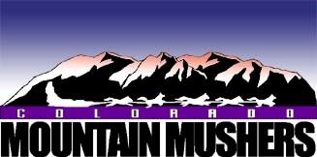

Colorado Mountain Mushers
2018-2019 Online Membership registration

- Individual Membership

Created by: Renee Kostreva
2018-08-26

Individual Membership:
- Next to member details select “1” for Number of Family Members.
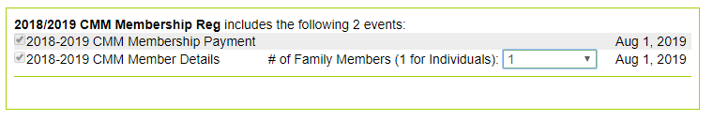
- Then select:
- You will have the option to register without an account, log in or create account. It is recommended to create an account as this will make race registration easier and a few other features, however it is not required. If you choose not to create an account skip to step 7.
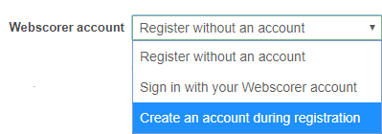

- If you choose to create an account, it will ask for email address and password.

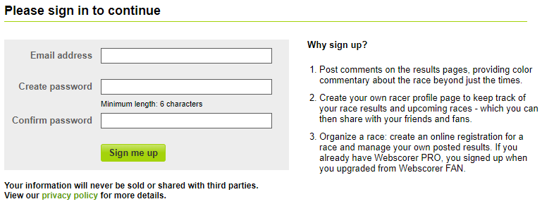

- Click Continue on the account successful screen.

- Who are you registering? Select “Yourself”
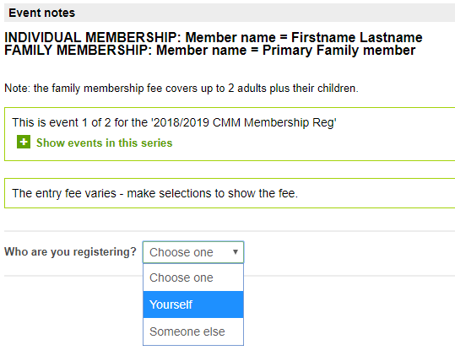
- Fill out Name and email address
- Select Membership type “Individual Membership”
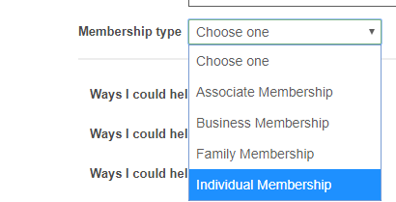
- Fill out additional questions.
- If you have a coupon code enter

- Click Calculate
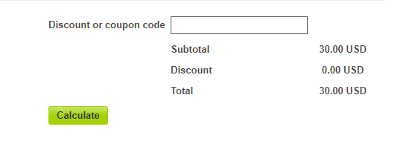
- Read the waver. click “I accept the terms of the waiver” check box and Enter Name.
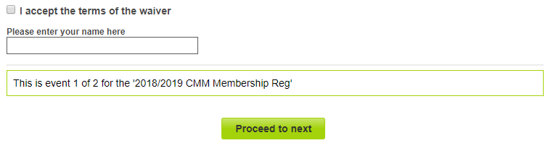
- Proceed to Next
- Complete Registrant info, Proceed to Confirmation page
- Event Payment Page, Select and you will be forwarded to Paypal to complete payment. If you do not have a Paypal page and do not want to create one you can pay with a credit or debit card.

- You will Receive a confirmation email from Webscorer confirming submition. Note if you use a checking account it may take a few days for the payment to clear.

Welcome to CMM!!!
@@@@@@@@@@@@@@@@@@@@@@@@@@@@@@@@@@@@@@@@@@@@@@@@@@@@@@@@@@@@@@@@@@@@@@
*** Note ***
@@@@@@@@@@@@@@@@@@@@@@@@@@@@@@@@@@@@@@@@@@@@@@@@@@@@@@@@@@@@@@@@@@@@@@
CMM will be accepting Paypal for upcoming race entries as well. It is recommended to set up a Paypal account as well as a Webscorer account to make entry and payment easier.
Also, Check out the Webscorer App! It is free and at sites with internet access we will have live scoring available!

