Family Membership:
- Next to member details select the correct qty for Number of Family Members.
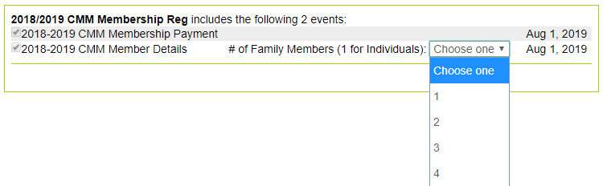
- Then select:
- You will have the option to register without an account, log in or create account. It is recommended to create an account as this will make race registration easier and a few other features, however it is not required. If you choose not to create an account skip to step 7.

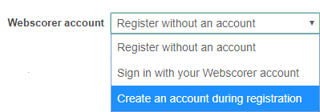

- If you choose to create an account, it will ask for email address and password.
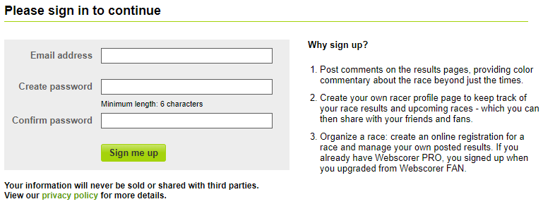

- Click Continue on the account successful screen.


- Who are you registering? Select “Yourself”.
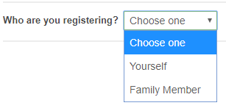
- Fill out Name and email address.
- Select Membership type “Family Membership”.
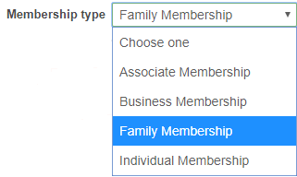
- Fill out additional questions.
- If you have a coupon code enter.
- Click Calculate.
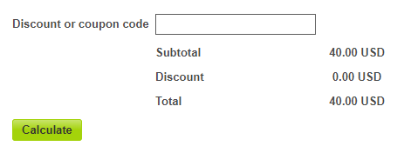

- Read the waver. click “I accept the terms of the waiver” check box and Enter Name.
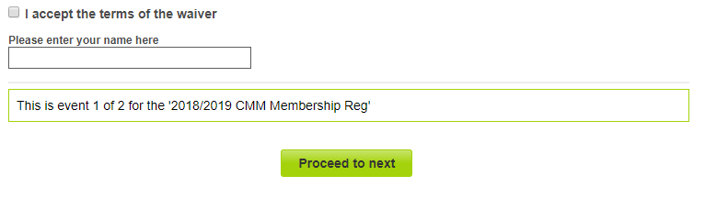
- Proceed to Next.
- Who are you registering, select “Family Member”.
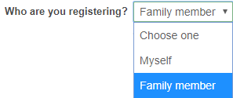
- Complete the same registration for each family member the same as above, once all are completed it will allow you to complete registration info.

- Complete Registrant info. Proceed to Confirmation page.
- Event Payment Page, select and you will be forwarded to Paypal to complete payment. If you do not have a Paypal page and do not want to create one you can pay with a credit or debit card.

- You will Receive a confirmation email from Webscorer confirming submission. Note if you use a checking account it may take a few days for the payment to clear.
Welcome to CMM!!!
@@@@@@@@@@@@@@@@@@@@@@@@@@@@@@@@@@@@@@@@@@@@@@@@@@@@@@@@@@@@@@@@@@@@@@
*** Note ***
@@@@@@@@@@@@@@@@@@@@@@@@@@@@@@@@@@@@@@@@@@@@@@@@@@@@@@@@@@@@@@@@@@@@@@
CMM will be accepting Paypal for upcoming race entries as well. It is recommended to set up a Paypal account as well as a Webscorer account to make entry and payment easier.
Also, Check out the Webscorer App! It is free and at sites with internet access we will have live scoring available!

